**REPORT**

By Ashima Yusuff

**1.INTRODUCTION**

**1.1 OVERVIEW**

The purpose of this project is to build an intelligent AI powered news app where the user interacts with the app UI to request relevant news content.

This is done with the help of an environment that include mining web application using JavaScript, Node.js, and the Watson Discovery service. At first, the app sends user requests to Watson Discovery News. The Watson Discovery Service is continually crawling the web to update its Discovery News collection. Next, the Watson Discovery Service responds to Slack search requests. Finally. The Watson Discovery Service seeds news articles to the client via Slackbot.

**1.2 PURPOSE**

The internet is home to enormous amounts of data that is updated every day. Organizations can connect this constant stream of information to gain understanding, plan strategies, and find opportunities. Enriched news data can help any application make dynamic connections across current events faster. An AI powered news app is thus created that helps to access one’s own news of interest has been created by mining web application using JavaScript, Node.js, and the Watson Discovery service.

**2. LITERATURE SURVEY**

**2.1. EXISTING PROBLEMS**

When we go through the news we come across all kinds of news. Different clients have different queries that they search, they may find some news are relevant to them while others completely do not capture their area of interest.

At times the clients can be adults, youngsters or even children and their queries need to be answered based on their preference of sentimental analysis. Children would prefer a more positive result to their queries whereas adults do not mind having a positive, negative or neutral result hence each news is rated based on its sentiment.

At times other details are hard to access directly like the author, main url and the url of the website of the news result.

**2.2. PROPOSED SOLUTIONS**

The AI powered news app has a collection of pre-enriched natural language processing, it can query not just on keywords or categories but also on concepts, sentiment, and relations to get richer search responses.

So based on the user the sentiment, relevant content and news of interest can be customized.

Other details including the author, main url or any other information is accessed directly on the user interface as its included in the Node-red Flow diagram.

**3. THEORETICAL ANALYSIS\**

**3.1 BLOCK DIAGRAM**

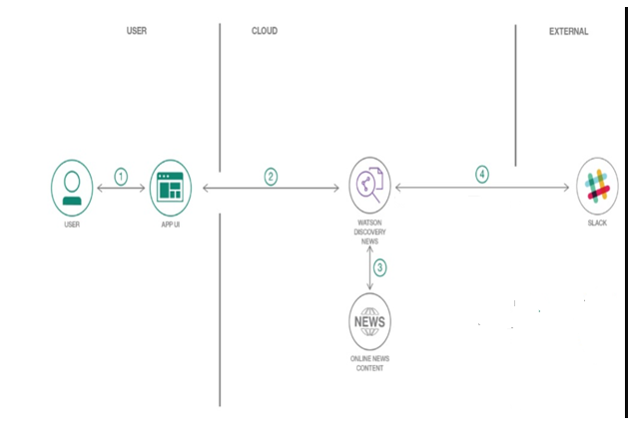

**3.2 SOFTWARE DESIGNING**

Different tools used in the software designing are as follows:

* Github: A web development platform used or version control. It helps to simplify the process of collaborating different projects. It works on files changes in the projects can easily be merged with the master branch of the project.
* [Watson Discovery](https://www.ibm.com/watson/services/discovery/): A cognitive search and content analytics engine for applications to identify patterns, trends, and actionable insights.
* [Node.js](https://nodejs.org/en/): An asynchronous event driven JavaScript runtime, designed to build scalable applications
* [React](https://reactjs.org/): Javascript library for building User Interfaces
* [Express](https://expressjs.com/): A popular and minimalistic web framework for creating API and Web server
* [Slack](https://slack.com/): Slack is a cloud-based set of team collaboration tools and services with chat bot integration
* [Botkit](https://www.botkit.ai/): Framework for creating and managing chat bots

**4. EXPERIMENTAL INVESTIGATIONS**

* If there is an error while deploying to IBM Cloud and if the Lite version is used then the memory space must be reduced from 256mb to 128 mb
* While making Node-red flow diagram some nodes are not included by default and needs to be downloaded from the pallete
* Code is written under each node in node-red flow diagram based on the application we want it to perform.
* While using the slackbot, RTM websocket must be opened at all times.
* A sequence of steps needs to be followed to ask any news to the slackbot.

**5. FLOWCHART**

CONFIGURE WATSON DISCOVERY

CREATE WATSON DISCOVERY SERVICE

BUILD NODE-RED USER INTERFACE

BUILD NODE-RED USER INTERFACE

QUERY WATSON DISCOVERY SERVICE

QUERY WATSON DISCOVERY SERVICE

PROCESS THE RESPONSE AND VISUALIZE

INTEGRATE SLACK WITH WATSON DISCOVERY SERVICE

SEARCH YOUR QUERY

**6. RESULTS**

Final node-red flow diagram

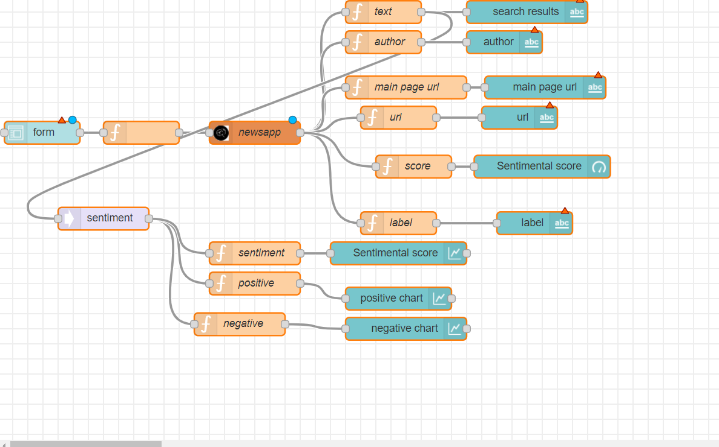

**The basic UI output is as follows:**

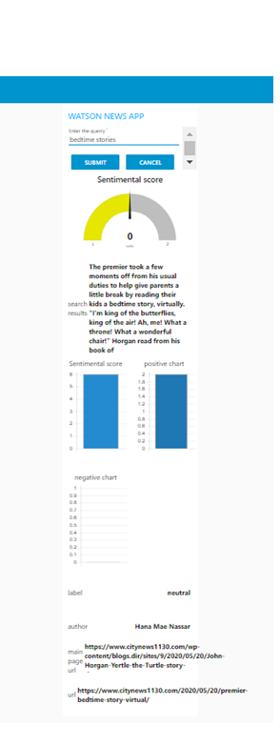

**7. ADVANTAGES AND DISADVANTAGES**

**ADVANTAGES OF THE AI POWERED NEWS APP**

* The app filters content based on keywords or categories and concepts, sentiment, and relations to get richer search responses.
* It analyses whether the news results are positive, negative or neutral as well as the data representation is shown using bar graphs.
* It displays the percentage of sentiment analysis of the news results using a pictorial gauge.
* Other details like the author, main url and the url of the page are displayed separately.

**DISADVANTAGES OF THE AI POWERED NEWS APP**

* The news results are searched based on keywords and the sentiment is analyzed and then chosen by the user based on his interest but we cannot directly search the news based on the required sentiment.
* While communicating with the slackbot, the users need to follow the below steps and cannot get the information by directly asking the bot for the news as in search engines

user: @helpbot hi

helpbot: Hello.

user: @helpbot news please

helpbot: Hi there! What news are you interested in?

user: @helpbot toronto raptors

helpbot: You want me to search for news articles about `toronto raptors`?

user: @helpbot yes

helpbot: OK searching...

* In the slackbot, RTM websocket must be opened at all times any interruption can lead to disconnection of the bot.

**8. APPLICATIONS**

* It can be used to interact with email inbox efficiently and the relevant emails is searched based on the keywords
* It can be a smart photo assistant that can be used to analyze whether people will like it more or not if posted on social media due to its feature of sentimental analysis.
* Can be used in professional networks
* It can be used to keep a record of all the news and queries searched.

**9. CONCLUSION**

An AI powered news app is built build where the user interacts with the app UI to request relevant news content based on keywords or categories and concepts, sentiment, and relations to get richer search responses. This is done with the help of an environment that include mining web application using JavaScript, Node.js, and the Watson Discovery service and using Slack environment.

**10. FUTURE SCOPE**

* This app can be used for facial recognition and matching it with database where clients enter their photo instead of keywords
* The bots can be configured to search content in other languages
* In professional networks, the database can be customized for a specific company and information can be accessed by the workers belonging to that company
* As this app keeps a record of all the searched history, it can be used in calendars to set reminders of specific date and events

**11. BIBLIOGRAPHY**

1. <https://cloud.ibm.com/login>
2. <https://www.ibm.com/cloud/get-started>
3. <https://developer.ibm.com/tutorials/how-to-create-a-node-red-starter-application/>
4. <https://nodered.org/>
5. <https://github.com/watson-developer-cloud/node-red-labs>
6. <https://www.youtube.com/watch?v=W3iPbFTAAds&feature=youtu.be>
7. <https://developer.ibm.com/articles/introduction-watson-discovery/>
8. https://cloud.ibm.com/docs/services/discovery?topic=discovery-getting-started
9. <https://www.youtube.com/watch?v=kwmqJRDbv98&feature=youtu.be>

**APPENDIX**

**NODE-RED FLOW DIAGRAM**



**UI URL:**

<https://node-red-uuwez.eu-gb.mybluemix.net/ui/#!/1?socketid=oDyMqAB-AdyN_dxUAAAk>